**Lab 1**

**Title:** Introduction to packet tracer simulation tools.

**Objectives:**

* To know about packet tracer
* To know the working environment of packet tracer and how to work with it.

**Theory:**

Packet Tracer, developed by Cisco Systems, is a versatile visual simulation tool that operates across multiple platforms. It empowers users to construct network layouts and replicate contemporary computer networks. This software facilitates the simulation of Cisco router and switch configurations through a virtual command line interface. The user interface of Cisco Packet Tracer is depicted in the accompanying figure.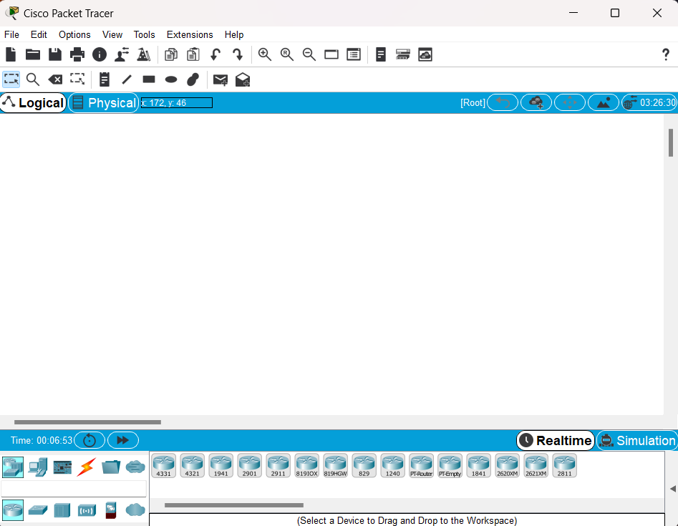

**Figure: Interface of Cisco packet Tracer.**

**Features of Packet tracer:**

* Unlimited devices
* E-learning
* Customize single/multi user activities
* Interactive Environment
* Visualizing Networks
* Real-time mode and Simulation mode
* Self-paced
* Supports majority of networking protocols
* International language support
* Cross platform compatibility

**Conclusion:**

The aim of this lab is to become familiar with cisco packet tracer and its working environment.

**Lab 2**

**Title:** Creating and configuring a simple peer-to-peer network having two PC’s and testing the connectivity between them.

**Objectives:**

* Implement peer-to-peer network using packet tracer.
* Testing connectivity between different computers present in the network.

**Theory:**

In peer-to-peer (P2P) networking, a group of computers collaborates with equal authority and duties for handling data processing. Unlike conventional client-server setups, no single device in a P2P network is solely devoted to serving or receiving data. Each interconnected machine holds identical permissions and can be utilized for the same functions as its fellow peers.

**Observation and findings:**

Implement peer-to-peer network in between two PC’s and testing connectivity between them. 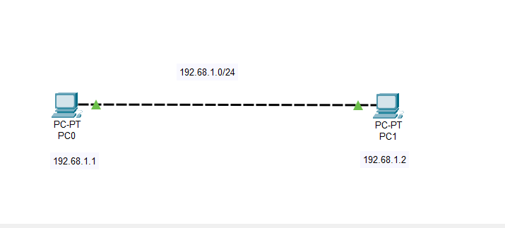

**Figure: Peer-to-Peer network**

**Output:**

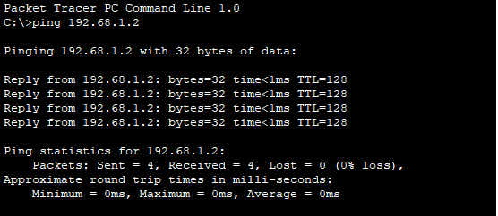

**Conclusion:**

The aim of this lab is to become familiar with peer-to-peer network using two PC’s.

**Lab 3**

**Title:** Creating a Local area network and testing the connectivity within the network.

**Objectives:**

* To create a local network using packet tracer and testing connectivity within network.
* To study in detail about local area network

**Theory:**

The phrase "Local Area Network" (LAN) denotes a network confined to a specific location. Typically, LANs operate within a small geographic area, often within a single building, and consist of two or more interconnected computers. These networks are frequently employed in home Wi-Fi setups and small-scale business networks.

**Observation and findings:**

Implement a local area network and testing the connectivity within the network.

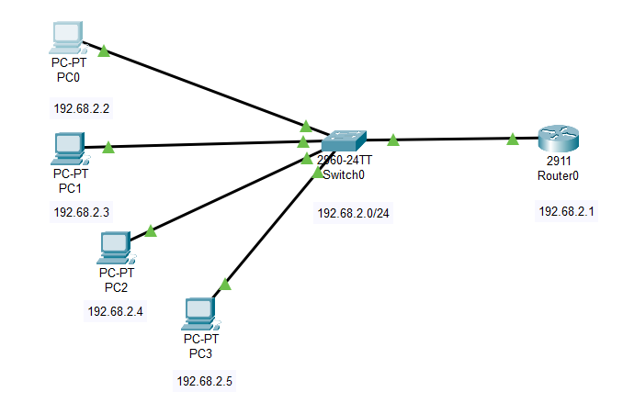

**Figure: Local Area Network**

**Output:**

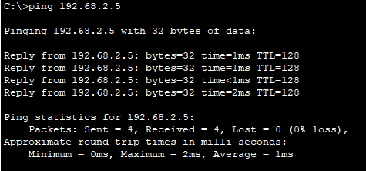

**Conclusion:**

The aim of the lab is to become familiar with Local Area Network

**Lab 4**

**Title:** Interconnecting two different LANs and testing the connectivity between them.

**Objectives:**

* To connect two different LANs using router
* To send data from one LAN to another LAN

**Theory:**

LAN interconnection involves linking two distinct LANs via a router. In this laboratory experiment, two separate LANs are employed to assess their connectivity. LANs are prevalent in both home Wi-Fi setups and small-scale business networks.

**Observation and findings:**

Interconnecting two different LANs and testing the connectivity between them

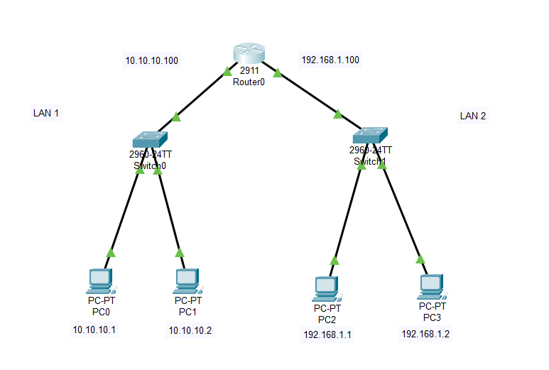

**Figure: Interconnection of Local Area Network**

**Output:**

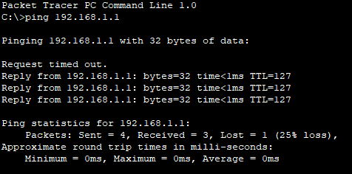

**Conclusion:**

The aim of the lab is to become familiar with LANs and their internetworking.

**Lab 5**

**Title:** Router Configuration using Command Line Interface

**Objectives:**

* To know about Router configuration.
* To know about command used in CLI.

**Theory:**

Network communication relies on routers to determine the optimal path to a destination and to forward traffic to the subsequent router along that path. Routing traffic between networks is the primary function of a router. Configuration of the router is essential to enable communication with your network components.

**Process for router configuration using CLI:**

* Enable router using command enable or en.
* Enter command configure terminal.
* Enter command line console 0.
* Set a password as you like.
* Exit
* Enable router using password.
* Go to the terminal using configure t command.
* Set a IP address and subset mask for GigabitEthernet of Router.
* Enable the ports of a router using no shutdown command.
* Enable IP address of a computer.

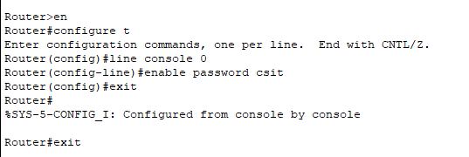

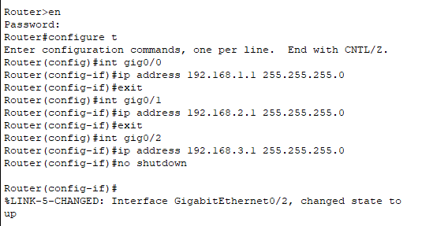

**Observation and findings:**

Configuring routers using Command Line Interface

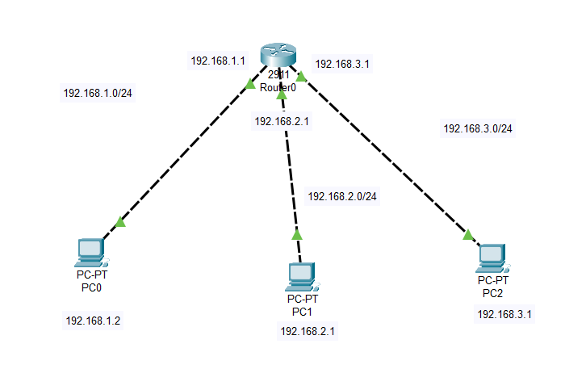

**Figure: Configuration of a Router**

**Output:**

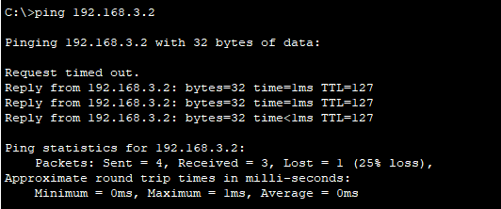

**Conclusion:**

The aim of the lab is to become familiar with Command Line Interface.

**Lab 6**

**Title:** Static Routing

**Objectives:**

* To know about Static Routing.
* To know how to give IP route to a router.

**Theory:**

Static routing involves a router utilizing manually configured routing entries instead of relying on dynamic routing traffic information.

**Process for static router:**

* Set a router with IP address.
* Setup switch and desktop for communication with IP address.
* Set another router with IP address
* Enable ports of a routers.
* Set a static route for Router one and two.
* Communicate from one network to another.

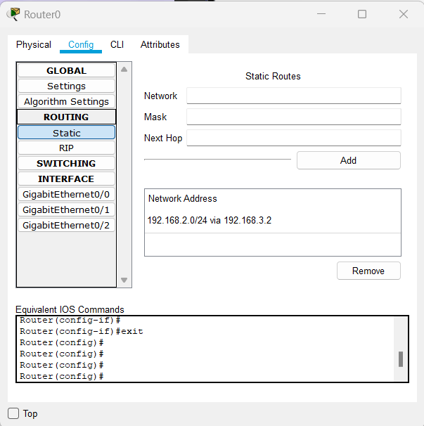

**Observation and Finding:**

Static Routing.

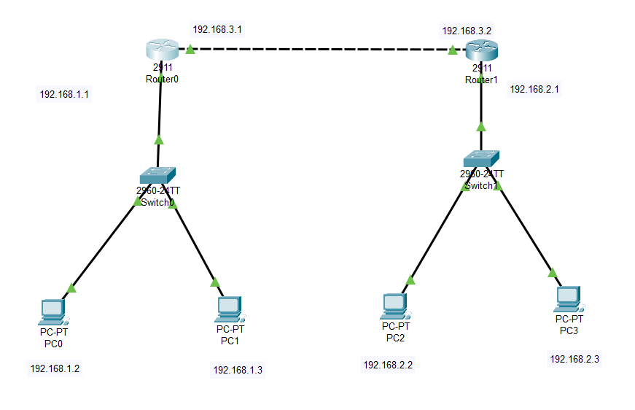

**Figure: Static Routing**

**Output:**

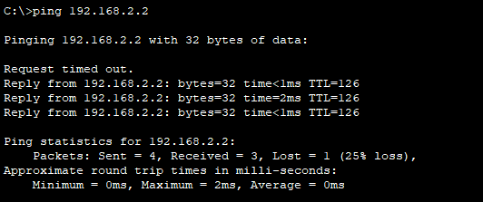

**Conclusion:**

The aim of the lab is to become familiar with Static Routing.

**Lab 7**

**Title:** Implementing Dynamic Routing Protocol RIP.

**Objectives:**

* To know about Dynamic Routing.
* To know RIP dynamic protocol.

**Theory:**

RIP (Routing Information Protocol) stands as one of the earliest distance-vector routing protocols, employing hop count as a routing metric to ascertain the optimal path from the source to the destination network. Functioning as a dynamic routing protocol, RIP operates at the network layer of the OSI model and carries an administrative distance value of 120.

**Process for static router:**

* Set a minimum three router.
* Setup switch and desktop for communication with IP address.
* Enable ports of a routers.
* Set a RIP network for routers using CLI or GUI.
* Communicate from one network to another.

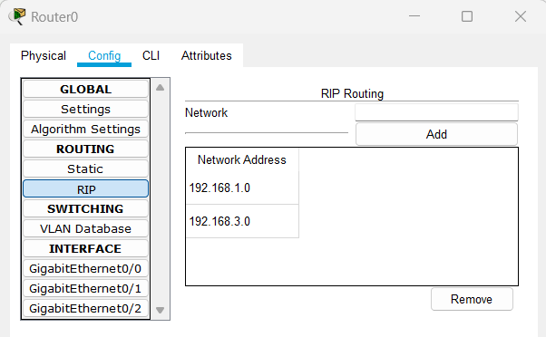

**Observation and Finding:**

RIP protocol for dynamic routing

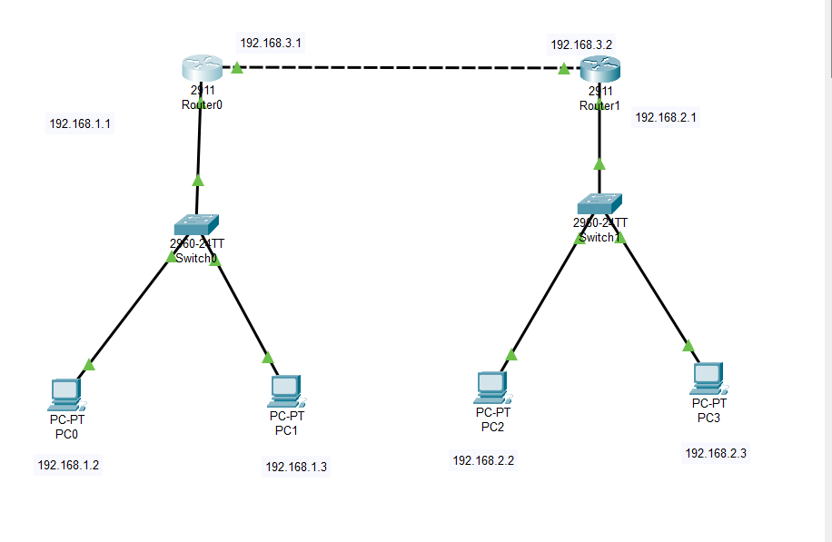

**Figure: Dynamic Routing RIP**

**Output:**

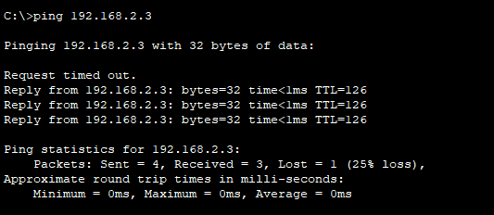

**Conclusion:**

The aim of the lab is to become familiar with Dynamic Routing Protocol RIP.

**Lab 8**

**Title:** Implementing Dynamic Routing Protocol OSPF.

**Objectives:**

* To know about Dynamic Routing.
* To know OSPF dynamic protocol.

**Theory:**

OSPF, short for Open Shortest Path First, represents a extensively utilized and endorsed routing protocol. This protocol is classified as an intra-domain protocol, indicating its utilization within a specific area or network. Functioning as an interior gateway protocol, OSPF has been specifically devised to operate within a singular autonomous system.

**Process for OSPE routing:**

* Set a minimum three router.
* Setup switch and desktop for communication with IP address.
* Enable ports of a routers.
* Set a OSPF networks for routers which are not directly connected first and then set connected networks using CLI.
* Communicate from one network to another.

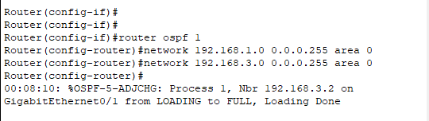

**Observation and Findings:**

OSPE protocol for dynamic routing

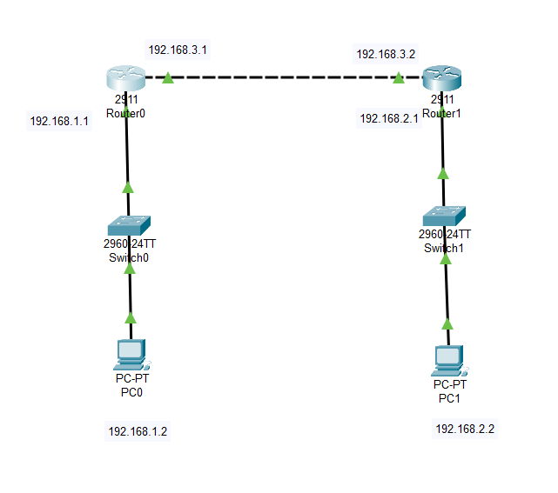

**Figure: Dynamic Routing (OSPE)**

**Output:**

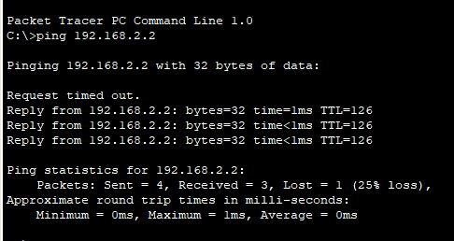

**Conclusion:**

The aim of the lab is to become familiar with Dynamic Routing protocol OSPE.

**Lab 9**

**Title**: Configuring DHCP server to assign IP addresses dynamically.

**Objective:**

* To know about DHCP server.
* To know how DHCP server assign IP addresses dynamically.

**Theory:**

The Dynamic Host Configuration Protocol (DHCP) serves as a network management protocol employed for automating the configuration process of devices within IP networks. This facilitates the utilization of network services like DNS, NTP, and various communication protocols based on UDP or TCP. Through DHCP, a server dynamically allocates an IP address along with other network configuration parameters to each device within a network, enabling communication with other IP networks.

**Process for DHCP Server to assign IP address:**

* Set a one router with one server and set a desktop as required.
* enable ports of a routers and set an IP address for both server and routers.
* Go to services of a server and on the service and assign the IP address of router in the server and set the start IP address.
* enable the DHCP in the IP configuration section of a desktop.

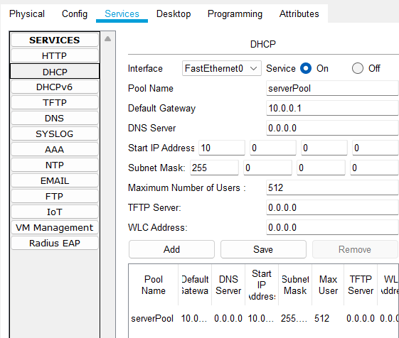

**Figure: Server Configuration (DHCP)**

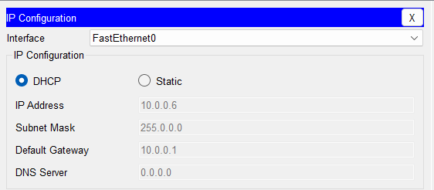

**Figure: IP assignment Dynamically (DHCP)**

**Observation and Findings:**

DHCP server IP assignment.

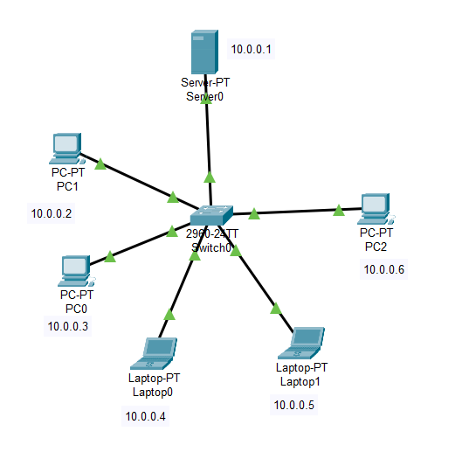

**Figure: DHCP server configuration (DHCP)**

**Output:**

**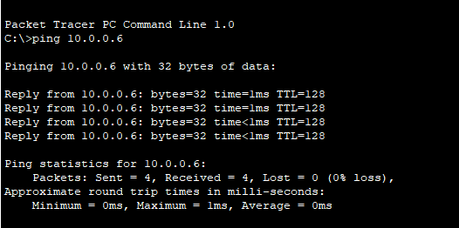  
Conclusion:**

The aim of the lab is to become familiar with DHCP server configuration.

**Lab 10**

**Title**: Configuring DNS server for domain name mapping.

**Objective:**

* To know about DNS server.
* To know how DNS server is used for domain name mapping.

**Theory:**

The Domain Name System (DNS) functions as the internet's mechanism for converting alphabetical names into numerical Internet Protocol (IP) addresses, akin to how a phone book links a person's name with their phone number. For instance, when inputting a web address (URL) into a browser, a DNS query is initiated to ascertain the IP address of the corresponding web server associated with that name.

**Process for DNS Server for Domain name mapping:**

* Set a one switch with one server and set a desktop as required.
* Set DNS IP address for a server and enable the DNS service.
* Go to services of a server and set the domain name and address for a DNS server
* Set an IP address for a desktop with DNS IP address.

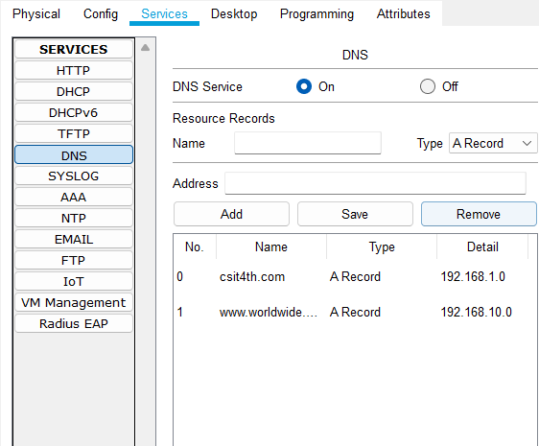

**Figure: DNS server configuration (DNS)**

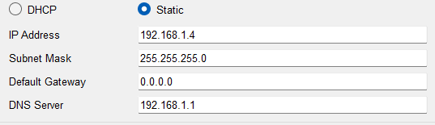

**Figure: DNS PC configuration (DNS)**

**Observation and Findings:**

DNS server for domain name mapping.

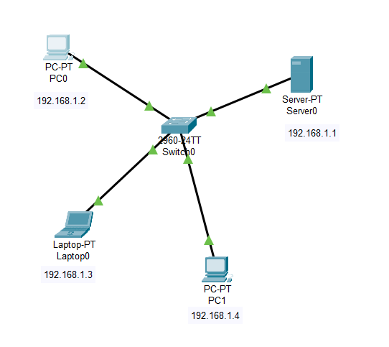

**Figure: DNS Server for domain name mapping (DNS)**

**Output:**

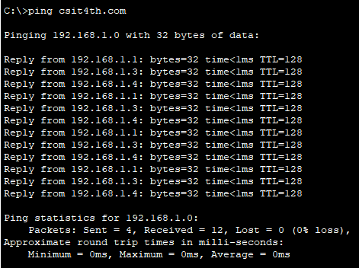

**Conclusion:**

The aim of the lab is to become familiar with DNS server.

**Lab 11**

**Title**: Configuring FTP server.

**Objective:**

* To know about FTP server.
* To know how FTP server is used to perform different file operation

**Theory:**

The main function of an FTP server is to enable users to transfer files both ways, i.e., upload and download. Essentially, an FTP server is a dedicated computer with an FTP address designed to accept FTP connections. FTP, standing for File Transfer Protocol, is the protocol utilized for transferring files over the internet between a sender (server) and a receiver (client). Serving as a hub for file access via FTP, an FTP server provides files for download and is widely used to facilitate remote data exchange among computers.

**Process for FTP Server for different file operation:**

* Set a one switch with one server and a router and set a desktop as required.
* Set Server IP address for a server and Router.
* Go to services of a server and set the username and password along with read, write, list, etc. as required in FTP section.
* Set an IP address for a desktop with Router IP address

**Figure: FTP server configuration (FTP)**

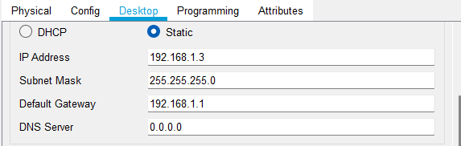

**Figure: PC configuration (FTP)**

**Observation and Findings:**

FTP server for different file operations.

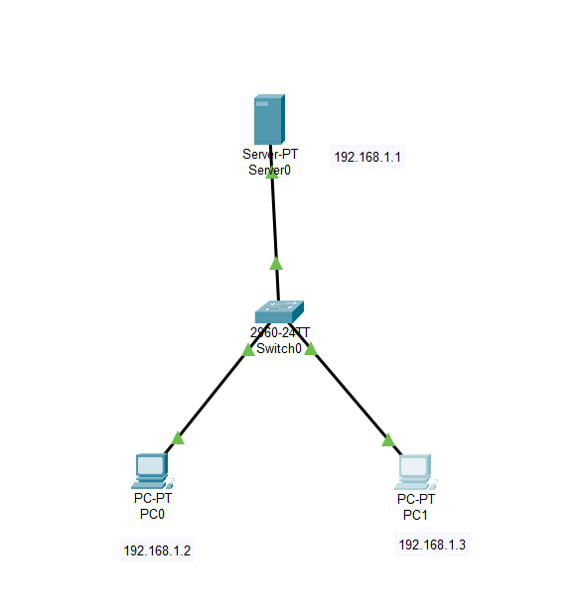

**Figure: FTP server for different file operations.**

**Output:**

For read file:

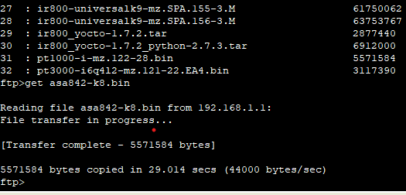

For delete file:

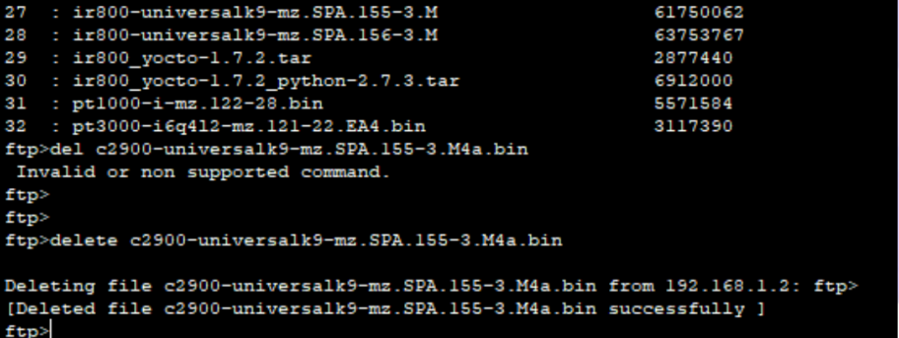

**Conclusion:**

The aim of the lab is to become familiar with FTP server file operation.

**Lab 12**

**Title**: Configuring Web server.

**Objective:**

* To know about Web server.
* To know how web server, perform http operation.

**Theory:**

A web server encompasses both software and hardware components, utilizing HTTP (Hypertext Transfer Protocol) and additional protocols to handle client requests across the World Wide Web. Its primary function revolves around presenting website content by storing, processing, and distributing webpages to users. In addition to HTTP, web servers also accommodate protocols such as SMTP (Simple Mail Transfer Protocol) and FTP (File Transfer Protocol), which are employed for tasks like email communication, file transfer, and storage.

**Process for configuring Web server:**

* Set a one switch with two servers and a router and set a desktop as required.
* Set Server IP address for both of a server and set one as DNS server and another as Web server.
* Set Router IP address.
* Set an IP address for a desktop with Router IP address as default gateway.

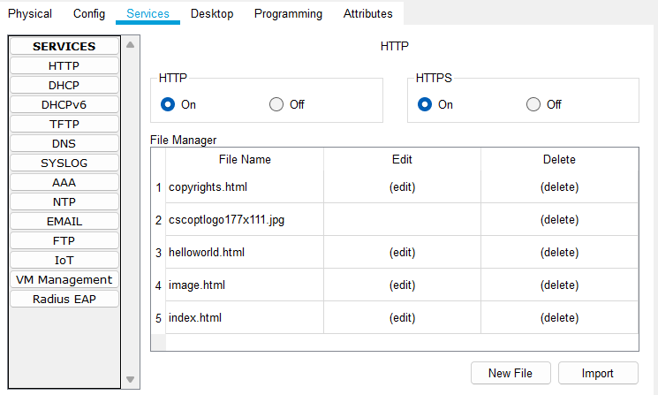

**Figure: web server configuration**

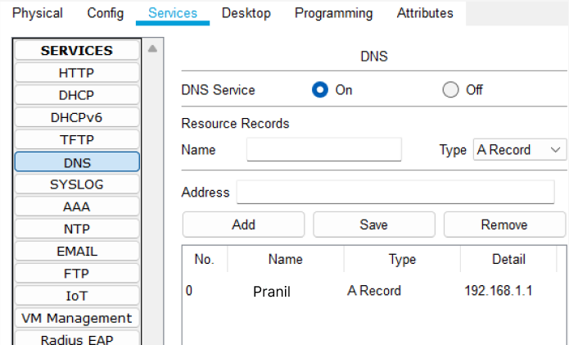

**Figure: web server DNS configuration**

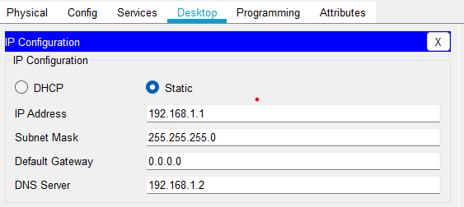

**Figure: web server Router configuration**

**Observation and Findings:**

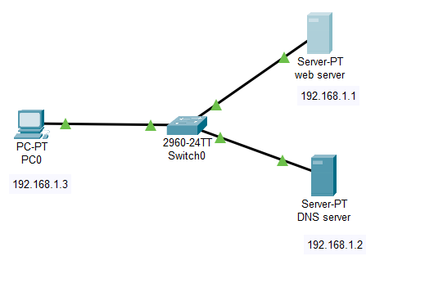

**Output:**

**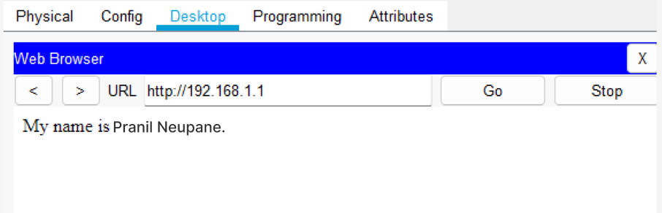  
Conclusion:**

The aim of the lab is to become familiar with web server.

**Lab 13**

**Title**: Capturing a packet and perform header analysis using wire shark.

**Objective:**

* To know about Wire shark.
* To know how wire shark interface.

**Theory:**

Wireshark stands as a no-cost, open-source packet analyzer utilized for network problem-solving, examination, software and communications protocol advancement, as well as educational purposes.

**Process for FTP Server for different file operation:**

* Open Wireshark application.
* Choose the interface of a Wi-Fi with live signal.
* click on a WI-FI to see the packets flow.
* observe a flow of a packets and detail of a packets in it.

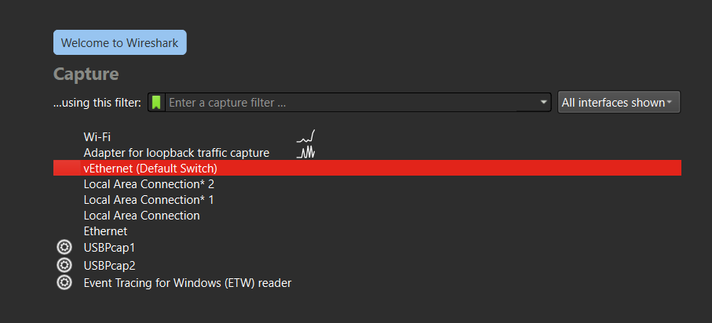

**Figure: Wireshark interface**

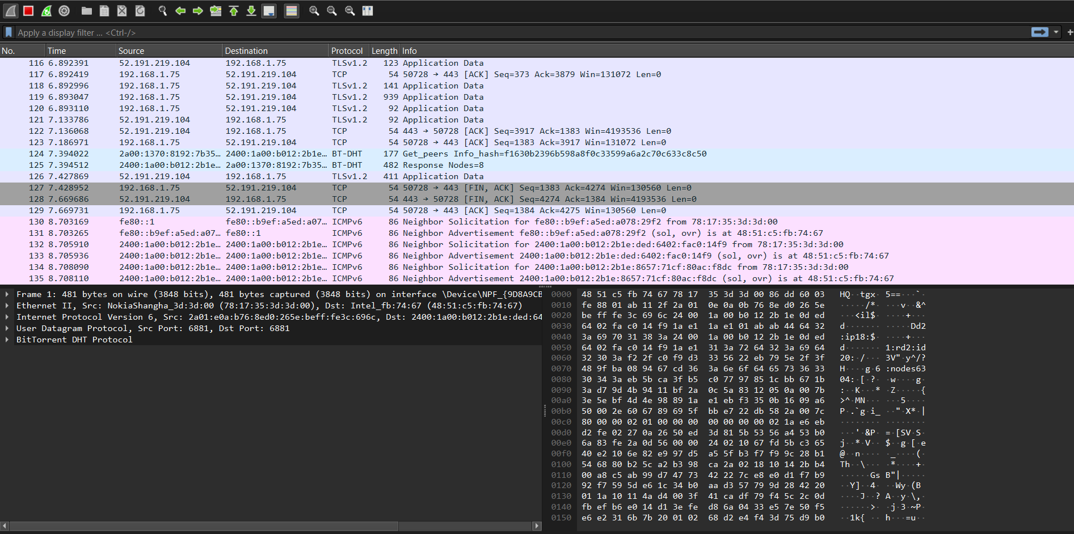

**Figure: Flow of Packet in Wireshark**

**Conclusion:**

The aim of the lab is to become familiar with Basic operation of wire shark.

**Table of contents:**

|  |  |  |  |
| --- | --- | --- | --- |
| S.N. | Lab report | Date | Signature |
|  |  |  |  |
|  |  |  |  |
|  |  |  |  |
|  |  |  |  |
|  |  |  |  |
|  |  |  |  |
|  |  |  |  |
|  |  |  |  |
|  |  |  |  |
|  |  |  |  |
|  |  |  |  |
|  |  |  |  |
|  |  |  |  |
|  |  |  |  |
|  |  |  |  |
|  |  |  |  |
|  |  |  |  |

**ST. LAWRENCE COLLEGE**



**Chabahil, Kathmandu**

**Subject: Computer network**

**Lab Report of Computer Network**

**Submitted by: Submitted to:**

Name: Pranil Neupane **Raj Kumar Shrestha**

Grade: **Bsc.CSIT(Fourth semester)**

External examiner Internal Examiner